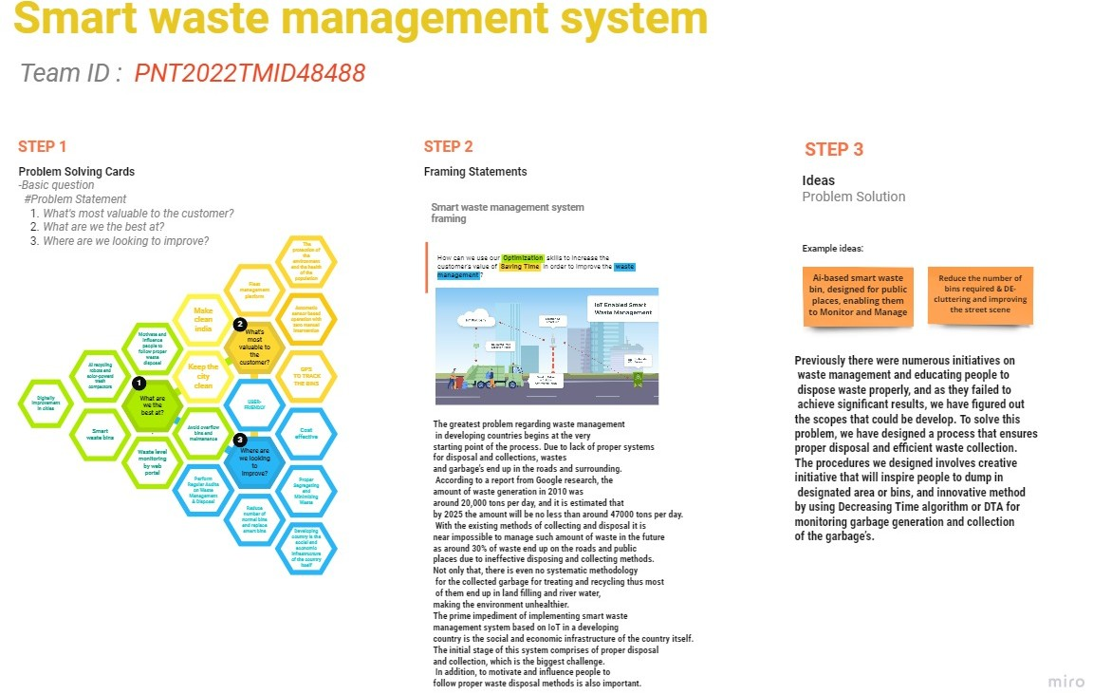

TEAM MEMBERS: Harshitha .M

Monisha . S

Nivedha . T

Pavithra . A

Sneha . J